**PRACTICAL NO: 07**

**AIM: Create MAC protocol simulation implementation for wireless sensor Network.**

**STEP 1:** Consider the following topology

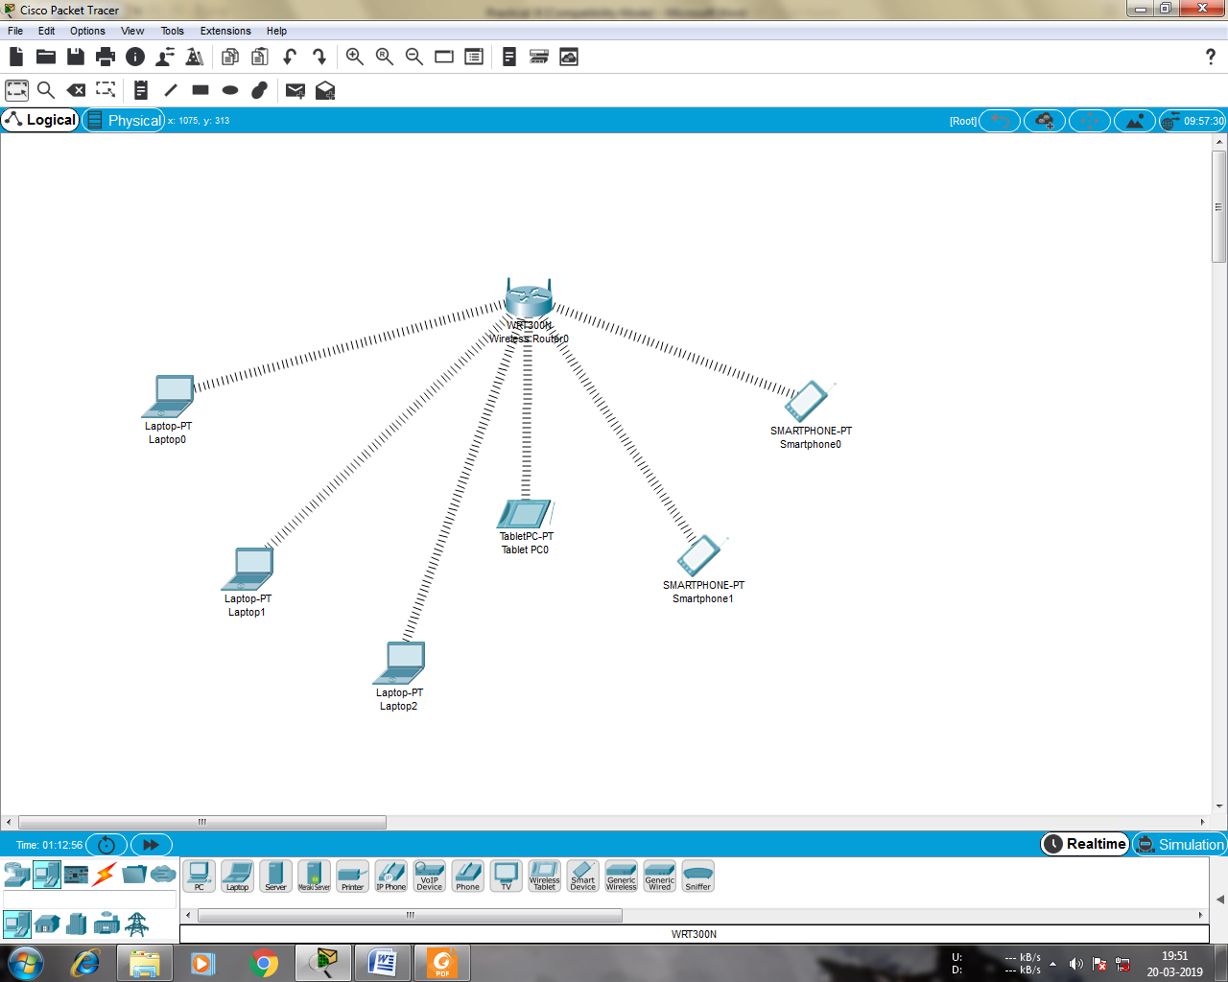

**STEP 2:** Adding the wireless interface to each Laptops

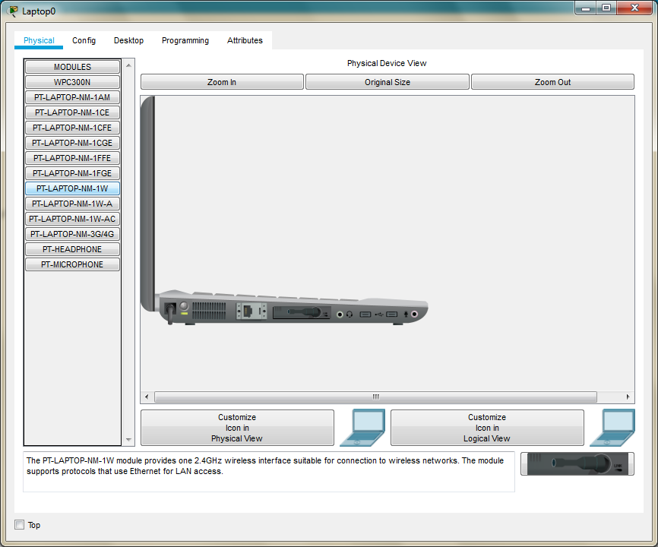

**STEP 3:** Copy the MAC address of each component as follows

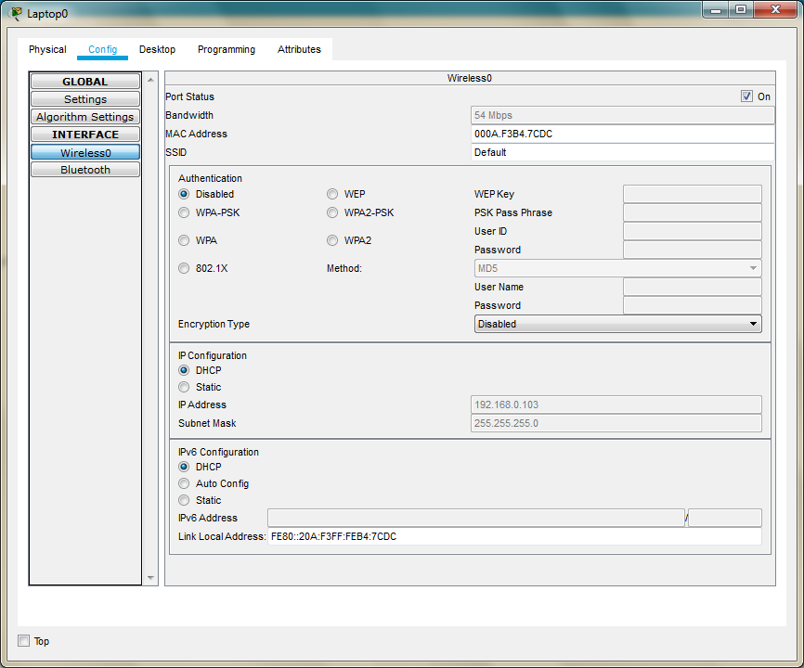

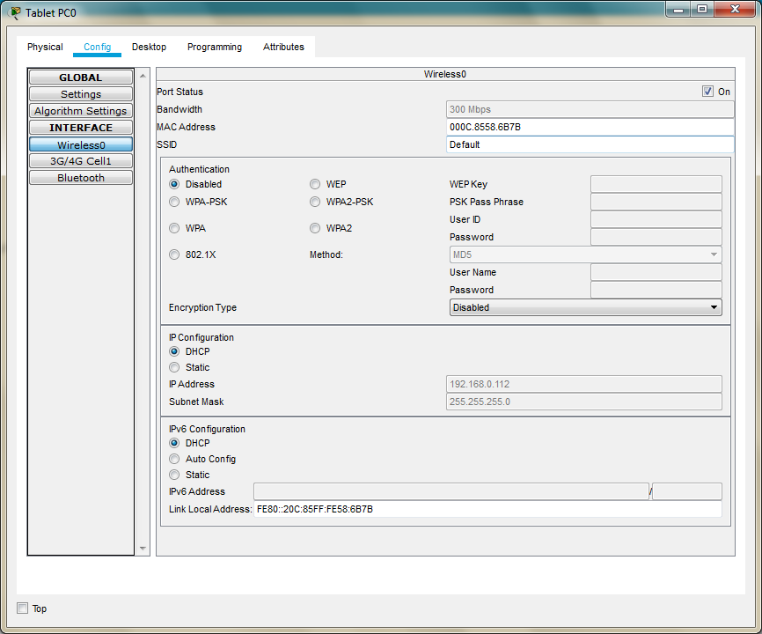

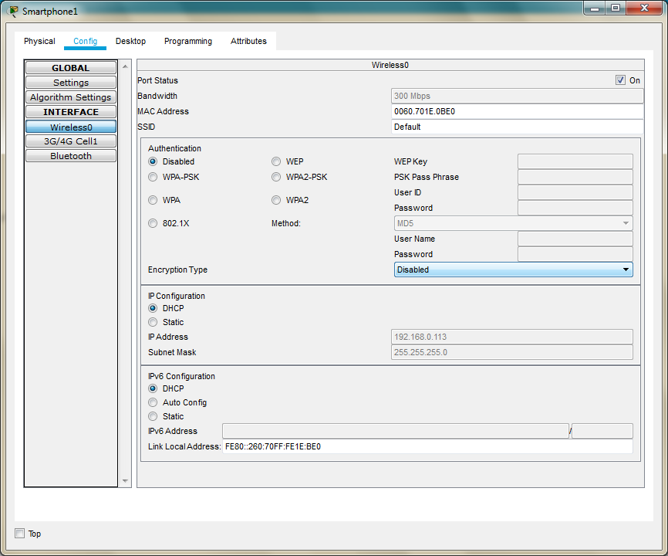

**STEP 4**: We note the following MAC addresses and convert them to the following form

|  |  |  |
| --- | --- | --- |
| **Component** | **MAC Address** | **Converted MAC address** |
| **Laptop0** | **000A.F3B4.7CDC** | **00:0A:F3:B4:7C:DC** |
| **Laptop1** | **0001.4269.6539** | **00:01:42:69:65:39** |
| **Laptop2** | **0060.5CB8.B919** | **00:60:5C:B8:B9:19** |
| **TabletPC** | **000C.8558.6B7B** | **00:0C:85:58:6B:7B** |
| **SmartPhone0** | **00D0.9774.32BD** | **00:D0:97:74:32:BD** |
| **SmartPhone1** | **0060.701E.0BE0** | **00:60.70:1E:0B:E0** |

**STEP 5:** Now we add few addresses in the wireless MAC filter of the Wireless Router and then use the given options for either allow or deny the Wireless access

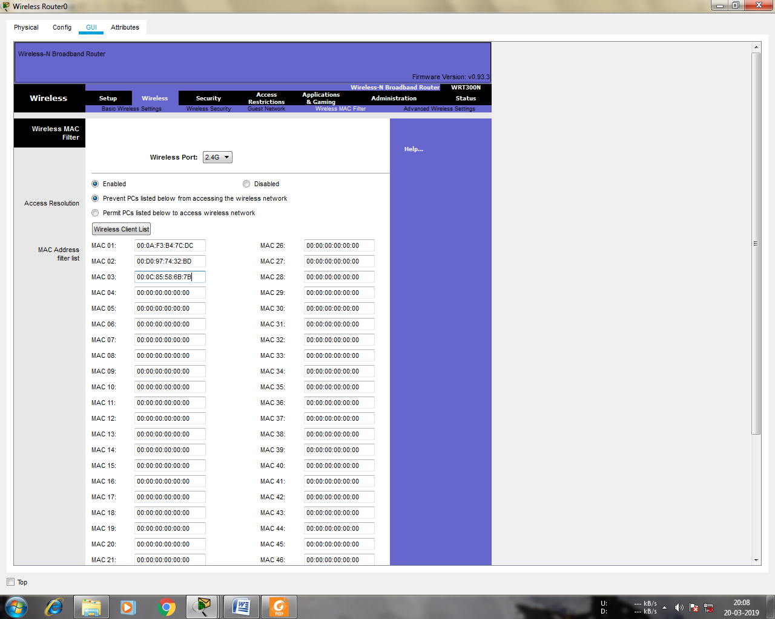

**STEP 6:** As seen in above screen shot we add the MAC address of Laptop0, TabletPC SmartPhone0 in the list so as to deny them accessing the Wireless network and then save the settings

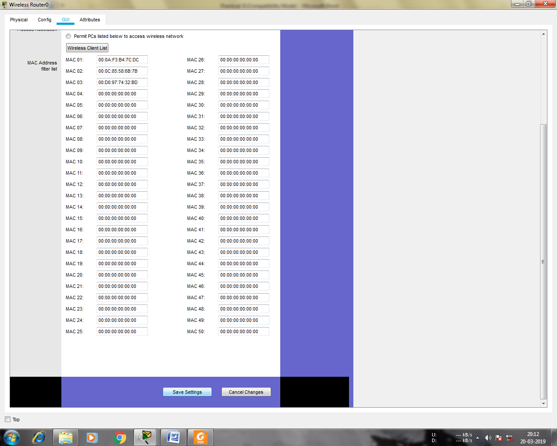

**STEP 7:** The result so obtained is as shown, the three devices denied any wireless connectivity

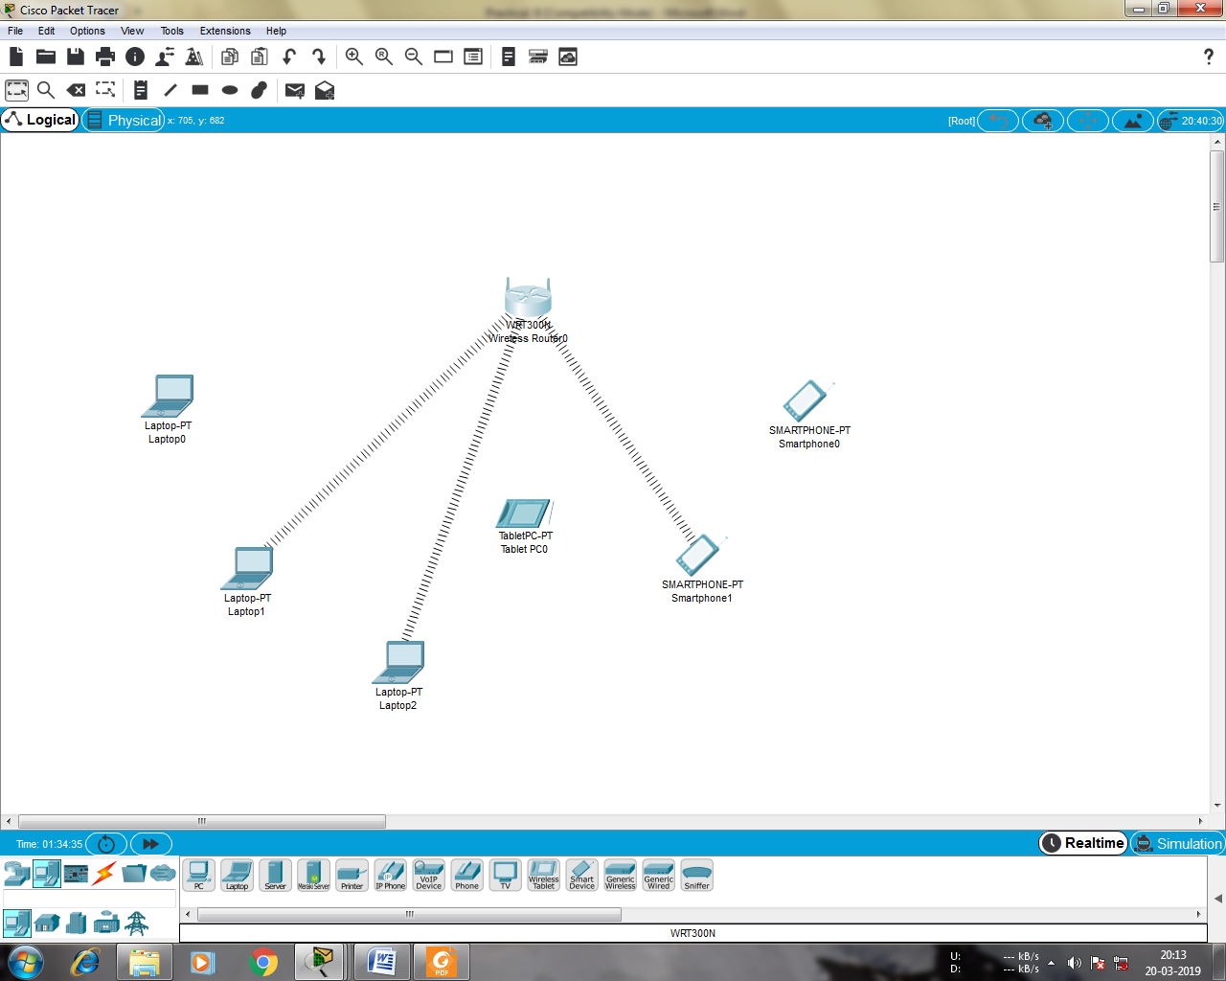

**STEP 8:** Similarly we can change the setting so that the above devices get wireless connectivity and the remaining devices do not get the wireless connectivity

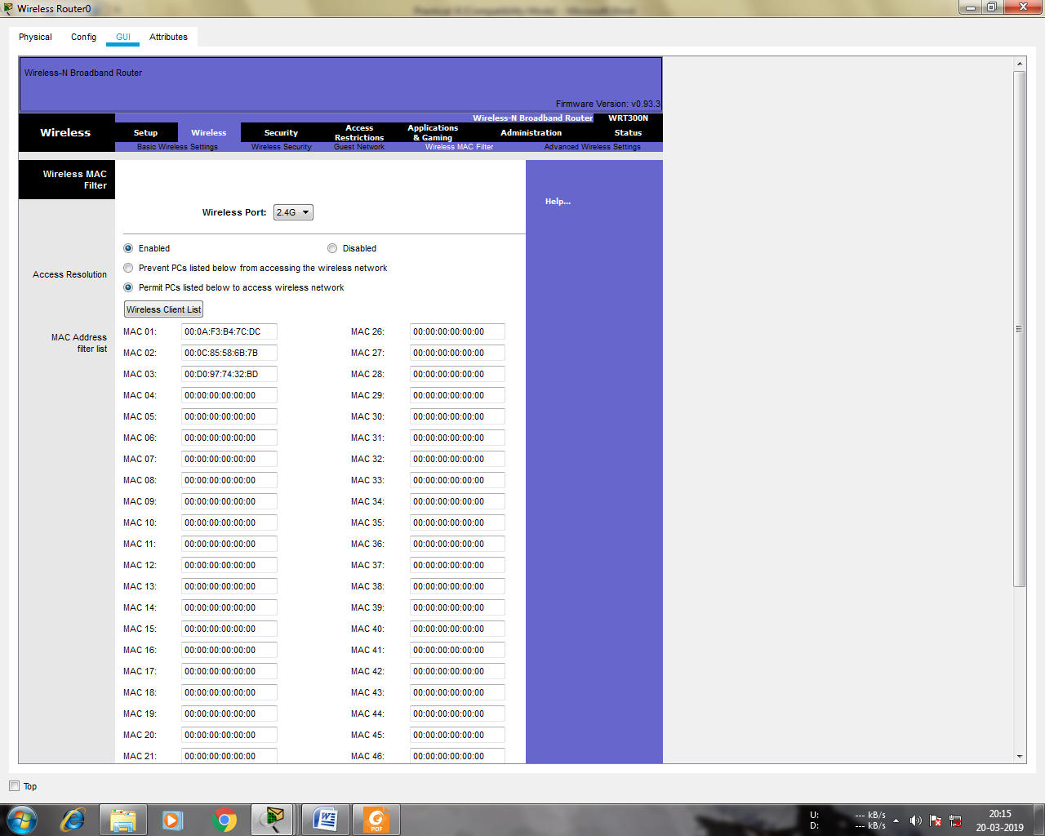

**STEP 9:** And save the setting and get the following

